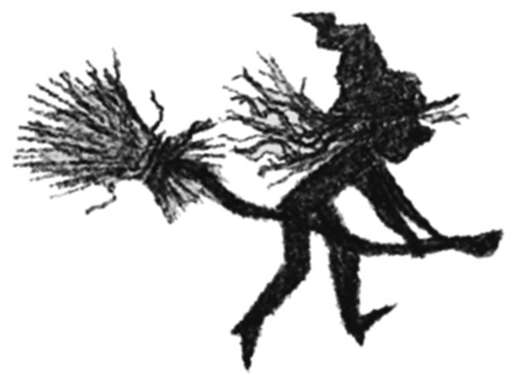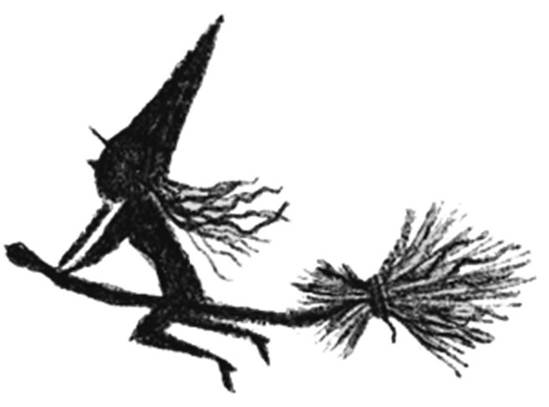

*Hag Storm*

Magic Spell

Competition Entry Form

Name: Class:

School Address:

Draw a picture of your spell ingredients - fill the whole box or draw them all on a

separate piece of paper if the box isn't big enough. Don't forget to label all of them!

Spell Instructions:

What effects will your spell have?