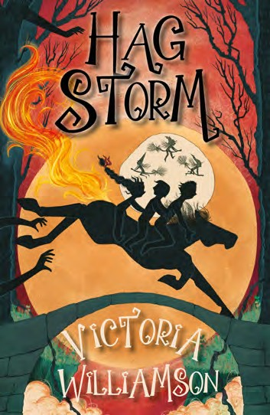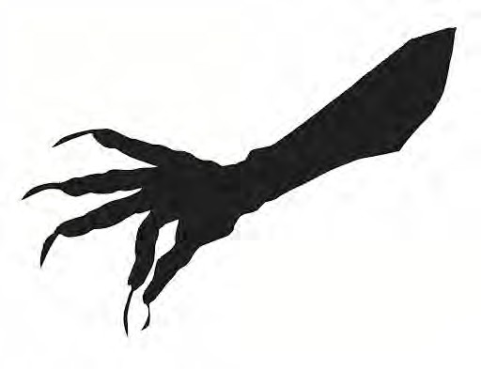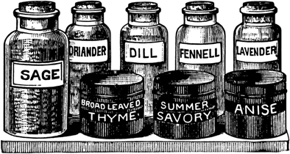

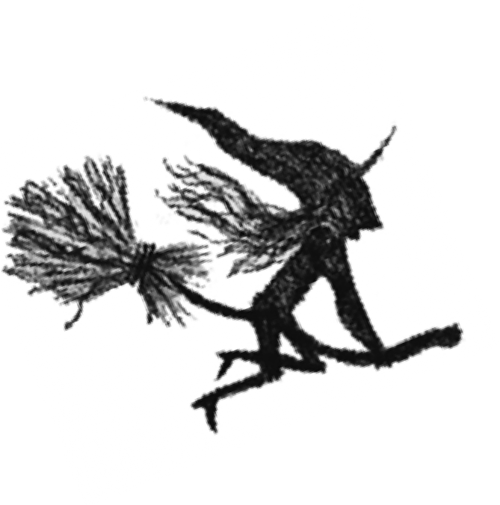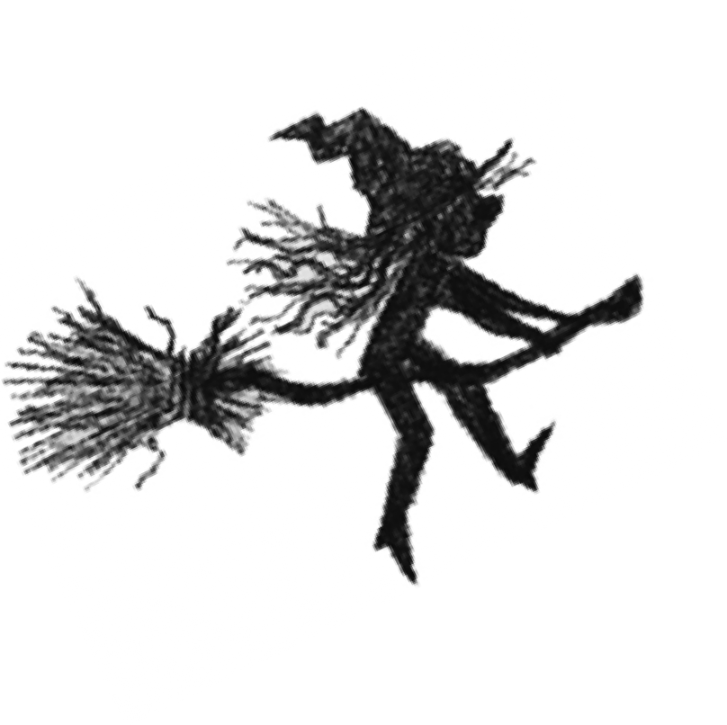

**Magic Spell Competition Rules**

•

The competition is open to any primary school pupils in P4, P5, P6 and P7, or Year 4, Year 5 and Year 6 - only one entry per pupil.

Spells must be original, but they can consist of real or imaginary ingredients.

The entrant's name, school address and primary class/year must be written clearly on the entry form

On the first page, draw and clearly label the spell ingredients you are using

- colouring these with pens or painting them will make them stand out!

Spell instructions and spell effects (good, bad, magical, funny, scary - be imaginative!) can be more than one page long (the entry form is just to give a rough guide of format) – please staple together any loose sheets to the pupil’s entry to ensure these are not lost.

The winner will receive a magic trick set and certificate.

Five runners-up will receive a crystal growing set and certificate.

Ten highly commended entrants will receive a certificate and a set of 'magic' colour change pens.

Twenty commended entrants will receive a certificate and a *Hag Storm* keyring.

All competition entries will be displayed on my website:

[www.strangelymagical.com/competitions](http://www.strangelymagical.com/competitions)

Closing date for entries is **Friday 4th March 2022.**

Please do not post entries to the Cranachan Books office, please email me for an address to post them to - thanks!

Alternatively, scanned entries can be emailed to me at [victoria.r.williamson@googlemail.com](mailto:victoria.r.williamson@googlemail.com) Please ensure all files have the pupil's name!

•

•

•

•

•

•

•

•

•

•

•

•

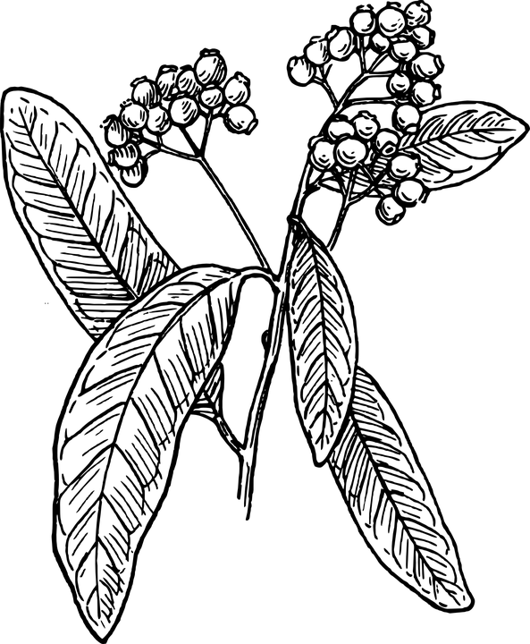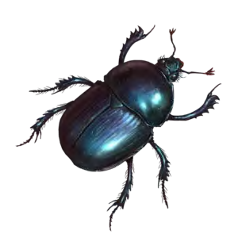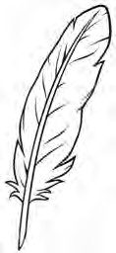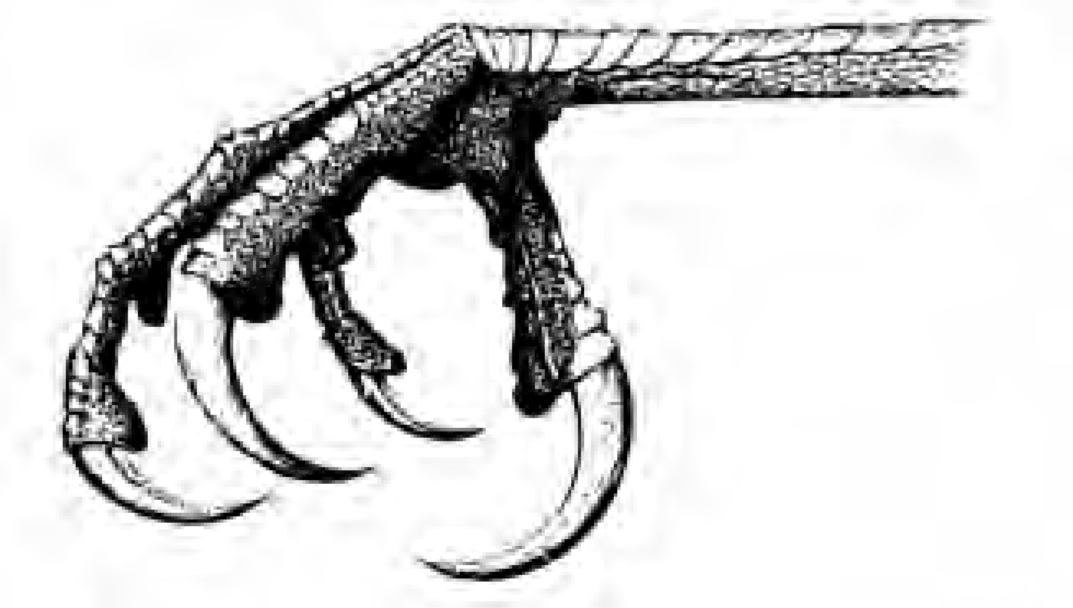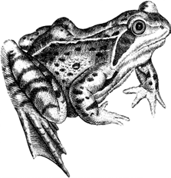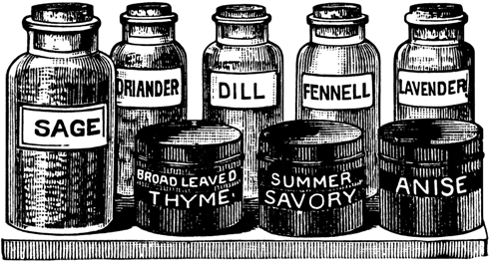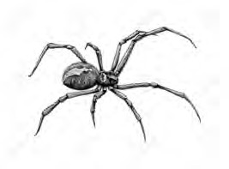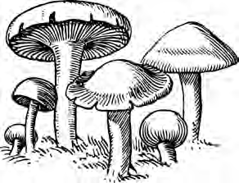

Not sure where to begin? Here's some inspiration from

*Hag Storm* to get you started!

Here are some of the items that were in the poultice bag that put a spell on Rab's family at Halloween:

*Raven's Claw - taken from a bird in mid- flight and sharpened with a silver blade*

*Deadly Nightshade*

*- picked from the Auld Kirk graveyard at the full moon*

*Magpie Feather*

*- found in the first ploughed field of autumn*

*Deathwatch Beetle - dried in an East wind and ground to dust*

*Warty Toad - pickled in vinegar and stiffed with stinging nettles*

*Earth Worm - chopped into thirteen pieces and roasted over a candle flame*

*Fresh Herbs - a pinch of Bogbean, sprinklings of Feverwort and Henbane, and a handful of wormwood.*

*Three spider's legs - dipped in curdled milk and wrapped in twine*

*Crow Skull - preserved in horse dung and buried in sand for seven winters*

*Toadstools - found growing beneath a wych elm at midnight*

You'll need to read the book to find out what effect this spell had!