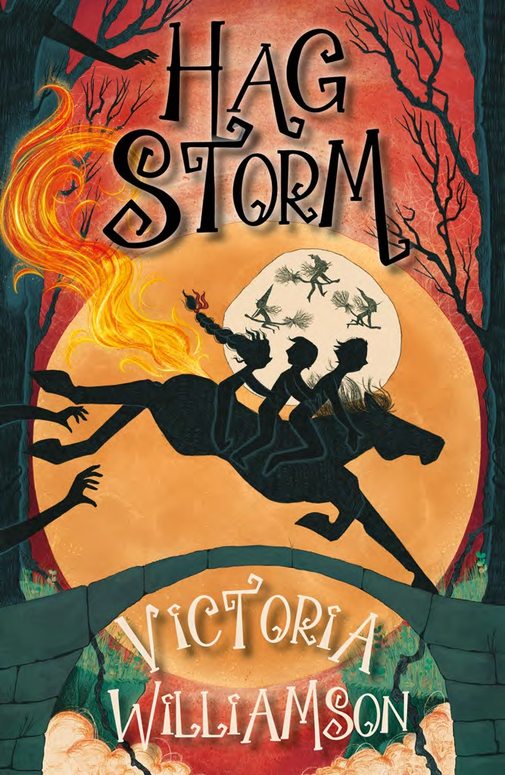

**Hag Storm Novel Study Pack**

A wide range of cross-curricular activities to explore the craft

of story writing, historical fiction, folklore and Robert Burns.

Curriculum for Excellence Level 2 and Key Stage 2 (Ages 8-12)

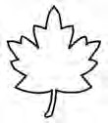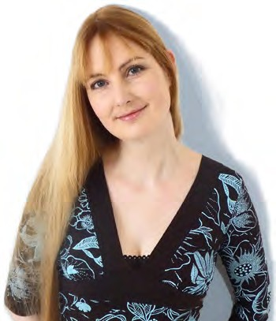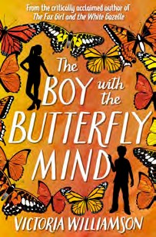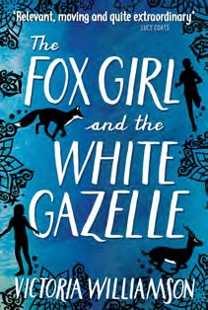

Introducing Hag Storm

***The witches are gathering...***

12-year-old Rab spends all of his time doing backbreaking work on his family’s farm instead of attending school, but when he finds a hag stone in one of the fields, everything changes.

Looking through its circular hole, he sees witches gathering in a coming storm, and they’ve set their sights on his family. Can Rab save his sisters from the clutches of the witches’ coven before their Halloween ceremony in the old kirk?

Filled with mystery and magic, Hag Storm is a spooky, historical adventure with a supernatural twist, based on the life of Robert Burns and one of his most famous and best-loved poems, *Tam O’Shanter*.

***About the Author:***

A lifelong storyteller and daydreamer, Victoria Williamson is a children’s author and teacher who has lived and worked in Africa, China, America and the UK.

Victoria grew up in Kirkintilloch, north Glasgow, surrounded by hills on the edge of a forest estate where many of her early ghost stories and fantasy tales were born amid the magical trees and spooky old ruined buildings.

Her previous novels, The Fox Girl and the White Gazelle, and The Boy with the Butterfly Mind (Floris Books) were based on her experiences of teaching children with diverse backgrounds and have been shortlisted for a number of awards.

Victoria is available for school visits and festivals – find out more information on her website: http: [www.strangelymagical.com](http://www.strangelymagical.com/)

or contact her at: victoria.r.williamson.googlemail.com

1

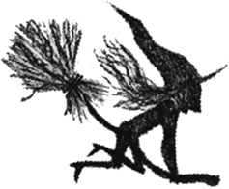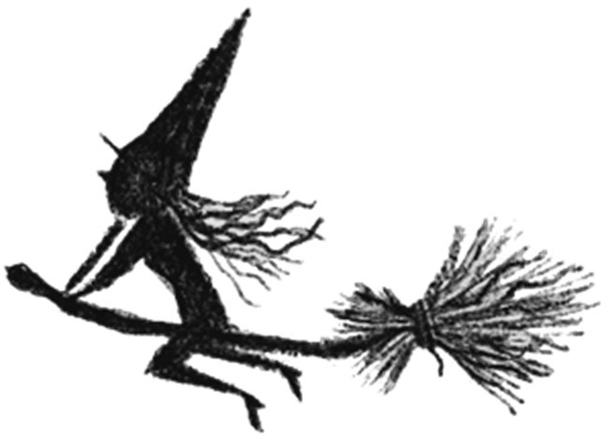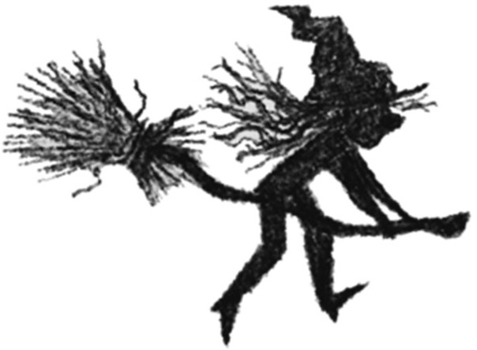

**Introduction - Book Cover Analysis**

In this activity, pupils will examine the main features of the book cover – the title, font, illustrations and blurb and discuss what can be learned about a book from these elements of the cover.

**ACTIVITY:** Look at the book cover in groups or individually, and complete Activity Sheet 1 (in the appendix) based on your observations and discussions.

**Chapters 1-2: Genre and Setting**

Genre

Genre is the ‘category’ of a story or the ‘type’ of story. It is determined by the subject, setting and plot of a story.

**DISCUSSION:** Read the blurb on the back of the book cover. It’s a story about Robert Burns as a boy. Discuss what you know about Robert Burns - how would you describe what type of story Hag Storm is based on what you know about Robert Burns?

**Suggested answer:** It’s a children’s book, and its genre is historical fiction – it’s a story set in a real time and place in the past (historical), but although the characters are based on real people, everything they do and say is made up (fiction).

**DISCUSSION:** Can you think of some other story genres you can read?

**Suggested answers:** Fantasy stories, science fiction, adventure stories, ghost stories, horror stories, crime fiction, mystery stories, contemporary fiction, humorous stories, romance stories, folktales, fairy tales and Westerns.

2

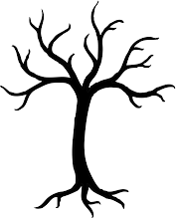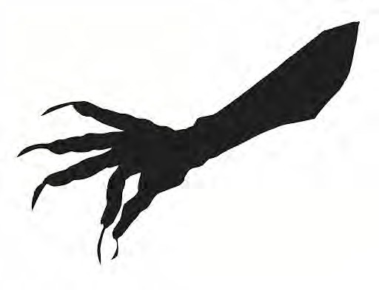

Setting

The story setting is where and when a story takes places. Does the story take place in a real or imaginary land? If it’s real, in what year is it set? Is the story set in a city or

in the countryside? Indoors or outdoors? If it’s indoors, what does the house or room look like? If it’s outdoors, what is the weather like? Is it night or day? Who is in this story? What kind of clothes are people wearing? What do they look like?

When you write a story, all of these little details will help to build up an interesting picture of the world you’re creating.

**DISCUSSION:** Brainstorm examples of setting in books that children are familiar with.

**Suggested answers:** Settings from books and films could include Hogwarts and Diagon Alley from Harry Potter, the wardrobe and the land of Narnia and from The Chronicles of Narnia, the Chocolate Factory from Charlie and the Chocolate Factory, the real world and the Wonderland from Alice in Wonderland, and the farm in Charlotte’s Web.

**READING -** Now read chapters 1-2 of Hag Storm, listening or looking for any clues about where and when the story is set.

**ACTIVITY: Complete Activity Sheet 2**



**Chapters 3-5: Characterisation - Character Description**

Descriptions of characters in stories are important to help readers build up a picture in their head of what characters look and act like.

**DISCUSSION:** Brainstorm some famous characters from children’s stories, such as Harry Potter, Cruella de Vil and Bilbo Baggins. Describe what they look like, and their main personality traits (their thoughts, feelings, and particularly, their behaviours).

**READING -** Now read chapters 3-5 of Hag Storm, listening or looking for any descriptions that can help build a picture of what some of the characters look like and how they behave.

**ACTIVITY:** Complete Activity Sheet 3.

**ACTIVITY:** Complete Activity Sheet 4.

**Chapters 6-8: Characterisation – Character Voice**

Narrative voice is the way the author tells a story. This novel is written in the third person – the author isn’t taking part in the action, but can see and hear everything that’s going on, and even knows what the characters are thinking. Character voice is the way each of the characters talk – their accent and local dialect, the words and phrases they use, and the tone of the words they use (this can be happy, sad, angry, humorous, bad-tempered, worried, etc).

**ACTIVITY:** How would you describe the way that Rab speaks? (Hint: think about his local dialect and the words that he uses). How many Scots words can you come up with that you remember characters using in the book so far?

**READING -** Now read chapters 6-8 of Hag Storm, listening to or looking at the way each of the characters speak. Pay particular attention to how the words they use can help you decide the tone of their speech.

**ACTIVITY:** Complete

Activity Sheets 5A & 5B.

4



**Chapters 9-10: Atmosphere**

The atmosphere of the story is the mood of the story, and how it makes you feel. Is it happy or sad? Scary or calm? Exciting or boring? Gloomy? Funny? Angry? Tense? Lonely? Hopeful?

The atmosphere can be built up by describing:

* The lighting where the action takes place (is it a sunny day, or a stormy night?)
* How the characters are feeling – what are their facial expressions and their actions like?
* What the characters experience with their five senses. What do they see, hear, smell, taste, or touch?
* How the characters are speaking and moving – are they angry? Scared? Excited? Happy?

**READING -** Now read chapters 9-10 of Hag Storm, looking or listening out for atmosphere clues like lighting, what can be seen and heard, how the characters are feeling, speaking and moving.

**ACTIVITY:** Complete Activity Sheet 6.

Often descriptions are written using ‘mood words’, which help the reader built up a sense of the atmosphere in the story. These are often adjectives or adverbs.

**ACTIVITY:** Complete Activity Sheet 7.

**ACTIVITY:** Complete Activity Sheet 8.

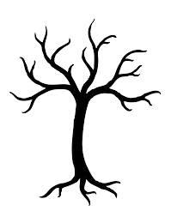

**Chapter 11- 13: Folklore**

Hag Storm draws on folklore to weave a tale of mystery and magic. Folklore is all of the traditional beliefs, customs and stories that communities pass down through the generations by word of mouth. Authors often use local tales as inspiration for their novels.

**READING –** Now read chapters 11-13 of Hag Storm, looking or listening out for mention of things connected to folklore. How many did you notice?

**ACTIVITY:** Complete Activity Sheet 9.

**Chapter 14: *Tam o’ Shanter***

*Tam o’ Shanter i*s one of Robert Burns’s most famous and best-loved poems. It inspired the story behind Hag Storm, and is often recited at Halloween or at Burns Suppers.

**DISCUSSION:** Have you read or heard *Tam o’ Shanter* before? What can you remember about the story of Tam and the witches? Read through the poem together, comparing the Scots version with the English translation:

<http://www.robertburns.org.uk/Assets/Poems_Songs/tamoshanter.htm>

**READING –** Now read chapter 14 of Hag Storm, paying close attention to Betty’s story of her friend Tam’s encounter with the witches. Can you find the places where her story and the poem are different?

**ACTIVITY:** Complete Activity Sheet 10.

6

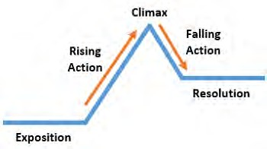

**Chapters 15-18: Story Pace**

The pace of a story is the speed at which the story is told. This is determined by how the narrator chooses to tell the story – the number of words used to write about an event, or the way the sentences are structured.

**DISCUSSION:** How does sentence structure change the pace of storytelling? Hint: think about what happens when there are more words and commas in a sentence, or when a paragraph is made up of lots of very short sentences with frequent full stops.

**READING –** Now read Chapters 15-18 of Hag Storm, listening out for parts of the story which seem to move quickly. Can you identify how the narrative style helps the action to unfold quickly in those scenes?

**ACTIVITY:** Complete Activity Sheet 11.

**Chapters 19-21: Story Structure**

Like many novels, Hag Storm follows a story structure called a narrative arc, which looks like this:



**•**

**Exposition:**

Exposition is just a big word that means all of the background information that readers are given at the beginning of the story , which can include: information

about the setting, characters, events that have happened before the story begins (such as Rab’s family moving from Alloway to the farm at Mount Oliphant), and the historical context of the book.

**•**

**Rising Action**

The Rising Action is often set off by a problem or conflict. This could be a mystery that’s uncovered, a disagreement between two characters, a quest that must be undertaken, or a difficult situation that is facing the main character.

This sparks the Rising Action, which includes a series of events where the pace of the story gets faster, and the stakes gets higher (the reader should be turning the pages faster at this point!)

**•**

**Climax**

All of the action reaches its peak at this point, and the characters face their big

moment.

**•**

**Falling Action**

This is where all of the parts of story come together, and the loose ends start to get tied up.

**•**

**Resolution**

This is where the story gets wrapped up and a satisfying ending is reached. It

doesn’t have to be a happy ending, but the mystery should be solved by this point, and the main character should reflect on what they have learned on this adventure.

**DISCUSSION:** What did you learn about the characters, the setting, and the historical context of the story in Hag Storm’s Exposition? What was the conflict or problem that set off the Rising Action? What events have taken place so far in the Rising Action?

**READING –** Now read Chapters 19-21 of Hag Storm, listening out for the Climax of the story, the events of the Falling Action, and the Resolution. Can you identify what Rab has learned by the end of the story?

**ACTIVITY:** Complete Activity Sheet 12.

8



**ADDITIONAL ACTIVITIES**

Social Studies – People, Past Events and Societies Rab mentions going out to the kailyard behind the

farmhouse. What is a kailyard? Do some research to find

out what this is and what people used to grow there.

Complete ACTIVITY SHEET 13.

**DISCUSSION:** Do you think the food Rab and his family ate would be healthy or unhealthy? If you had to eat this food every day, what would you enjoy, and which modern food items would you miss?

Social Studies – People, Place and Environment

Growing up on a farm in rural Scotland, the landscape around Rab would have changed with the seasons. Every season there would have been different crops planted on the farm, and wild plants, flowers and berries would grow at different times of year.

**DISCUSSION:** At which time of year do the events of Hag Storm take place? There are lots of types of plants mentioned in Hag Storm. Can you name some of them?

(Suggested answer: potatoes, cabbage, apples, brambles [blackberries], oak tree, ivy, carrots, oats, yew tree, nettles, mistletoe, nightshade, holly, herbs, horse chestnut trees).

Complete ACTIVITY SHEET 14.

Social Studies – People, Past Events & Societies/ Expressive Arts – Art & Design

Corn dolls play a big part in the story of Hag Storm. What are these, and why did people in past centuries make them? Do some research online and share your findings with the class.

You can make your own Halloween ‘corn doll’ using wool. Follow the instructions on:

[https://www.wikihow.com/Make-a-Yarn-Doll](http://www.wikihow.com/Make-a-Yarn-Doll)

and see how many different designs you can come up with!

9



Expressive Arts – Art and Design

The cover for Hag Storm was drawn by artist Elise Carmichael. When artists design book covers, they start with a design brief. This includes lots of words and phrases from the book which might help them think up a scene for the cover.

**DISCUSSION:** Which words, phrases and names from the book do you think Elise based her cover design on? Which scene from the story is being portrayed in the illustration?

Complete ACTIVITY SHEET 15.

Literacy

Look again at the original Scots version of *Tam o’ Shanter:*

<http://www.robertburns.org.uk/Assets/Poems_Songs/tamoshanter.htm>

**DISCUSSION:** Can you identify the rhyme scheme in this poem? Can you identify some words in this poem that help to set the scene and build up the Halloween atmosphere?

Complete ACTIVITY SHEET 16.

10



**APPENDICES**

**Activity Sheet 1 – Book Cover Analysis**

Look at the front of the book cover and answer the following questions:

Title

•

•

What images does the title conjure up in your head?

What three words would you use to describe the font the title is written in? (‘Font’ is the type and shape of text).

What do you think the book might be about based on the title and font?

•

Illustrations

•

•

What can you see in the picture? Describe it.

Who do you think some of the characters in the story might be based on the cover? Describe them.

What do you think the book might be about based on the illustrations?

•

Now read the blurb at the back of the book.

•

What words does the publisher use that let you know where and when this story takes place?

What words does the publisher use to make the story sound exciting?

What do you know about Robert Burns? Which of his poems do you think inspired this story?

•

•

11



**Activity Sheet 2 – Setting for Chapters 1 and 2**

Read through chapters 1 & 2, and complete the tables describing the settings for both chapters:

12

**SETTING – CHAPTER 1**

Your Answer

Pick some words and phrases from the chapter that helped you decide on your answer

**When?**

Time of day:

Time of year:

Historical period:

**Where?**

Indoors or outdoors?

Place:

Describe it:

**Who?**

Main characters:

Other characters mentioned:



13

**SETTING – CHAPTER 2**

Your Answer

Pick some words and phrases from the chapter that helped you decide on your answer

**When?**

Time of day:

Time of year:

Historical period:

**Where?**

Indoors or outdoors?

Place:

Describe it:

**Who?**

Main characters:

Other characters mentioned:



**TEACHER SHEET:** Suggested answers for Activity Sheet 2

14

**SETTING – CHAPTER 1**

Your Answer

Pick some words and phrases from the chapter that helped you decide on your answer

**When?** Time of day:

Time of year:

Historical period:

* Daytime – lunchtime
* Evening – super time
* Autumn - October

In the past, before farm machinery was invented and blacksmiths repaired tools. A time when children had to go out to work, and people wore clogs if they couldn’t afford shoes. A time when £100 was a huge amount.

-The sun shone gold on the newly harvested fields

-he sat down on the rock and ate his lunch

-By the time the sun was setting

-Are you coming in for your supper?

-Mount Oliphant looked pretty enough in October

-Looking west in the full glow of autumn

-wheat threshing

-plough horses

-other fathers can afford to hire labourers, and their boys can go to school

-clogs

-the princely sum of the hundred pounds

-I’ll take the hoe to the smithy

**Where?** Indoors/ outdoors?

Place:

Describe it:

* Outdoors
* Farm fields
* Mount Oliphant – a farm on the hilltop
* Close to Ayr

A field on a hilltop farm near Alloway and Ayr, with a view of the sea.

Poor farmland, and cold and damp in winter.

-Gil poked the hard mud again

-the boys danced through the mud

-barren fields, newly harvested fields

-Mount Oliphant looked pretty enough in October

-their hilltop farm

-the bustling town of Ayr in the distance

-The Atlantic Ocean stretched out to the distant horizon

-south-west towards the Heads of Ayr

-small farms nestled in the gently rolling hills,

-The land was so poor it was sucking the life from them

**Who?** Main characters:

Other characters mentioned:

* Rab Burns – 12 years old
* Gil Burns (Rab’s younger brother)
* Rab and Gil’s father, William
* Their sister, Agnes Burns

-Rab’s five brothers and sisters (including Gil and Agnes), and another baby, Isabella

* Their cousin, Betty
* A strange figure dressed in black

-I’m twelve and more

-I’m turned eleven

-They turned to see their father in the lane

-aiming his anger at his younger sister

-The baby coming in June hadn’t helped

-Isabella crying through the night

-he had five brothers and sisters already

-If I was as superstitious as our Cousin Betty

-black-robed figure crossing the fields in the distance



**TEACHER SHEET:** Suggested answers for Setting in Chapter 2

15

**SETTING – CHAPTER 2**

Your Answer

Pick some words and phrases from the chapter that helped you decide on your answer

**When?** Time of day: Time of year:

Historical period:

* Night time
* Supper time
* Coming up to Halloween

A time in the past when water came from a pump outside, food was cooked over a kitchen fire, cottages had a bed set in the kitchen wall and blacksmiths used bellows. Ayr Library Society was founded in 1762, and the Bengal famine mentioned was in 1770, setting this story in 1771 when Robert Burns was twelve,

-this twilight hour

-his choice of topic for supper conversation

-Whit the bairns want to hear about is the gathering of the witches at Halloween

-the pump in the yard

-stirring the bubbling pots on the kitchen fire

-the bed set in the wall

-the smithy’s bellows

-the Ayr Library Society

-You’ll be able to find Bengal on the map then?

-last year’s famine is back

**Where?** Indoors/ outdoors?

Place:

Describe it:

* Beginning and ending outdoors
* Mostly indoors
* A farmhouse five miles away from Ayr
* The kitchen

A farm made up of a farmhouse, barn and byre

A small farmhouse with a warm kitchen where food is cooked on over fire. A bed is set in the wall, and everyone sits round the kitchen table to eat.

-they walked together down the track to the farmhouse

-then stopped by the pump in the yard

-Rab was glad to [...] step into the warm glow of firelight inside the house.

-the townsfolk five miles away in Ayr

-The old woman hobbled round the kitchen

-the three small buildings that made up their farm

-the house, barn and byre looked like they were hunched up against the cold

-the warm glow of firelight inside the house

-the bubbling pots on the kitchen fire

-When all the children were sitting down, their father said grace, giving thanks for the food that was on the table

**Who?**

Characters:

Rab Burns

Gil, William Burns, Isabella

Betty Davidson, Rab’s old cousin Agnes – 9 years old

Rab’s younger siblings– Nannie, Willie and John

Rab’s mother

The old horse, Meg

-Rab was glad to leave the darkness behind

-Gil put in, poking Rab playfully

-the frown lines in his father’s forehead deepened

-stroking Isabella’s tiny hand

-he recognised the old woman standing before him as his mother’s cousin

-when he was only nine [...] at the same age

-Nannie, you can show Rab the socks later

-Willie, that shoe would look better on your foot

-John [...] The youngest boy didn’t look convinced

-give his mother a kiss on the cheek.

-That old nag?



**Activity Sheet 3 – Character description**

Read through chapters 3 to 5, picking out the words and phrases that describe characters, and write a short description of each of the characters below:

16

**Character**

**Words and phrases from the novel**

**Your description**

Meg, the horse

Factor McNab

Morven, the maid

Betty Davidson



**TEACHER SHEET:** Activity Sheet 3 Suggested Answers – List of words and phrases to help describe each character

Factor McNab:

•

•

•

•

•

•

•

•

•

•

•

•

•

a mean spirited factor

the factor spends more time hanging about the Fergussons’ kitchens trying to cadge a free meal than he does at his own house

the tyrant factor

the polished boots of Factor McNab

clipping his words like the city gents he was always imitating

his beady eyes getting narrower below his ridiculous powered wig his pudgy, beef-fed face

The factor might dress like a dandy instead of the jumped-up farmer he used to be, but his hands had lost none of the steely grip he’d learned from years guiding a plough

A pompous man like him would no more take his wig off in public than a woman would go to a ball in her nightgown

“Let me pass!” he commanded, pushing his way through the crowd instead of waiting his turn

McNab’s rude behaviour

For all the tinsel and baubles he wore, a man like Angus McNab wasn’t any better than the rest of them underneath

the factor gave up any pretence of patience and shoved past the last two people in his way to get to the door, knocking one of them over as he ran outside and hurried down the road

Betty Davidson:

•

•

The new maid Morven was right. Betty Davidson was a witch.

Fine families like the Fergussons had their own pew stalls at the front, but the poorer folk sat towards the back, making way for their betters. Right at the far end of the church, on the pew nearest the door, sat Betty Davidson

She wasn’t listening to the minister either. She was staring at the girl a few rows ahead of her

Betty Davidson was an old woman, and a plain one at that.

Her nose was hooked, and her pointed chin jutted from her deeply lined face like a rocky crag on the coastline.

When she laughed, the few teeth she had left wobbled in her gums, and her grey eyes were cloudy from years spent hunched over cooking fires.

She wasn’t a pretty picture like Morven

“Pox-ridden son of a she-goat!” Betty muttered behind McNab’s fleeing back. “I hope you choke on your fine beef dinner and it stops your heart dead, you mean wee—” “Vain wee minx,” Betty growled. “She’s no worth the air she’s breathing.”

That put Betty in a sour mood, and no mistake. She refused to be taken to see Doctor Campbell and insisted on going straight back to the cottage. She wouldn’t let the family cook dinner for her either, and shut the door behind her with curt thanks when they walked her home. She didn’t even invite them in to warm their feet by the fire.

“Let the wee minx go, Rab!” Betty said, charging out behind her like she was chasing rats from a barn. “A mouthful of dirt’s the very thing she deserves.”

•

•

•

•

•

•

•

•

•

17



Morven, the maid

•

•

•

•

•

•

•

•

a pale-faced ghost of a girl who looked about sixteen, with eyes the colour of pine trees in winter

the crimson blood staining her hands and spattering her apron when she parted her white lips, her teeth were bared at him like fangs

the dark stains on her hands and apron were actually smears of blackberry juice her green eyes full of cat-like curiosity

the girl laughed, flashing her white teeth again

there was something in the pale, wistful look of her face that made him want to sit at the table all day talking to her

Morven’s dark hair was hidden beneath a neat white cap, but the sun from the high windows glinted on the curls that escaped, giving them a sheen like polished mahogany.

Her green eyes were narrowed in concentration as she took in every word the minister was saying, her pale hands folded in her lap as though she was praying. She looked like a picture of a saint Rab had seen in a book once, as if she was weighed down with sorrows, but was too good a soul to burden others with her troubles

Maybe then she’ll tame that smile of hers and it’ll be a bit less wild. Rab wouldn’t forget in a hurry what an idiot he’d been when he’d first seen her white teeth in the gloom of the scullery and thought she was baring a set of fangs at him

There was a much larger crowd of young men gathered round the other person McNab had shoved. Even though she hadn’t fallen down or hurt herself, there were so many arms extended to help Morven that it looked like she was surrounded by the spokes of a giant cartwheel

Morven came marching out, her green eyes blazing and her teeth clenched in anger Morven’s bottom lip trembled, and she turned her face away so the old woman wouldn’t see the tears welling in her eyes

Morven’s frown softened as she gazed at Agnes, and a wistful smile of remembrance flitted across her pale lips

Morven’s eyes narrowed in the cat-like way Rab had seen before in the scullery, and her voice took on a soft purring note that showed she was pleased at his sister’s words despite her protests

•

•

•

•

•

•

•

•

Meg, the horse:

•

•

•

•

The old Clydesdale had once been a fine plough horse, but now her brown hide was flecked with grey and hung in sagging folds round her bones

slowly clomping away with him down the lane

He jumped down and led the wheezing horse the rest of the way on foot, giving her time to recover

Meg reared up, whinnying in fear. Rab had to bribe her with some of his stolen apples to calm her down again, and even then she refused take a single step into the graveyard

“In a minute, I’m going to put Meg in the byre first,” Rab called. The old horse would’ve been just as happy tied up by the front door and lunching on the flowerpots

•

18



**Activity Sheet 4 – Character Description**

The way that Rab, Gil and Agnes look isn’t described in great detail in the novel, but can you come up with your own descriptions of them based on everything you’ve read so far?

What do you know about them by the end of chapter 5? How do they speak and behave? What do you think they look like?

Write a short description for: Rab Burns

Gil Burns

Agnes Burns

19



**Activity Sheet 5A – Character Voice (dialect)**

Make a list of all of the Scots words you’ve come across so far. The first few are done for you to start you off:

Wilnae, aye, jings,

Can you remember what the following Scots words used in Chapters 1-8 mean?

20

**Scots word**

**Meaning**

gowk

bogle

midden

tatties

bairns

kelpies

smithy

tawse

sheugh

brambles

kirk

biggin

birkie

bannock



**Activity Sheet 5B – Character Voice (tone)**

Look through chapters 6-8 and find examples of the following (the first one is done for you as an example):

21

Word tone that suggests:

Quote from chapters 6-8

Which words helped you to decide?

Agnes being scornful

“Och, away!” Agnes snorted, giving the door a sharp rap with her knuckles. “We’ll no drown in a wee drop of rain, you big daftie!”

‘Och’ and ‘away’ suggest Agnes thinks Rab is talking nonsense and ‘big daftie’ shows she’s making fun of him.

Another example of Agnes being scornful

Betty disliking Morven

Agnes admiring Morven

Rab sounding accusing

Agnes being upset

Morven being kind to Agnes



**Activity Sheet 6 – Atmosphere (Chapter 9)**

Look more closely at some of the passages in chapters 9, and fill in the table to analyse the atmosphere in each part of the story. The first one has been done for you to get you started.

22

**Part of the story**

**What can be seen, heard, smelled, tasted or touched?**

**Howa are the characters feeling, speaking or moving?**

**How would you describe the atmosphere in this part of the story?**

After supper, Rab can’t find the stone, and goes to bed. (Pages 81-82)

Snoring can be heard (Rab’s father) Candlelight flickering Shadows creeping

Rab’s mother speaks ‘sleepily’

Rab is tired (he could ‘barely keep his own eyes open’) Rab’s heart raced

Rab is exhausted

A little tense and threatening despite being peaceful. (Everyone is tired and sleepy, but the candlelight and shadows are ominous)

Rab wakes up and finds the hens haven’t laid any eggs (Page 82)

The family have breakfast together

(Pages 84-85)

Rab sees a figure by the water pump (Page 86)

After dinner, the buttermilk is spilled (Pages 90-91)



**Activity Sheet 7 – Atmosphere (Chapter 10)**

Look at these passages from chapter 10. Underline all of the mood words you can find, and discuss how they help build up an atmosphere in the story:

‘He headed for the one place he felt sure the darkness in the stone wouldn’t be able to escape from: the hallowed ground of the old kirk.

It was still early morning, and the mist from the River Doon shrouded the churchyard in wispy white tendrils, cold and insubstantial as the fingers of a ghost. Just for a moment, Rab thought he saw a flicker of firelight coming from the far end of the kirkyard.

He went to investigate, stepping carefully over the crumbled remains of gravestones until he came to the small building at the back. It was about the size of a large hen house, but much grander, with stone pillars on either side of the entrance gates and grinning gargoyles set round the sloped roof.’

‘Rab shivered and looked around for a suitable place to bury the stone. He didn’t want to disturb any of the graves that sat sombre and silent in the tangled undergrowth, so he headed for the yew tree that grew near the entrance of the crumbling kirk. Cousin Betty had told him one night that the sacred trees were grown in churchyards to prevent the rising of ghosts and apparitions, their roots holding the dead firmly underground. If anything could keep the evil in the stone from returning to haunt him, it was the ancient yew.

He rounded the corner of the wall and stopped dead. Something was moving inside the old kirk.

Rab stumbled back, ducking down behind the statue of a weeping angel that guarded the ruins of a headstone. He peered through the gloom, his eyes narrowing when he saw that the woven image of the Devil was still standing on the threshold of the church, the straw dog’s muzzle facing him menacingly.’

‘Every hair on the back of his neck prickled, urging him to run, but he gritted his teeth and crept forward, hiding behind the thick trunk of the yew tree. He had to get to the bottom of this. He had to find out what all the frightening omens meant and where they were coming from. Most of all, he had to find out how to stop them.

When he gazed into the dark belly of the abandoned kirk, one of his questions was answered. He now knew for certain where the dark signs were coming from. But that only deepened the mystery of *why.*

A familiar figure was hobbling round the crumbling walls, her eerie chants echoing in the broken rafters. Rab couldn’t make out Cousin Betty’s words, but they weren’t in any language he’d ever heard. Through the thick screen of ivy and weeds, he could see her placing more straw dolls on the empty windowsills where glass had once been. The figures were ugly and misshapen, their heads too big for their bodies and their arms and legs long and spindly. Rab was sure they were demons, witches, and all manner of unnatural creatures.’

23



**Activity Sheet 8 – Atmosphere (Mood Words)**

List some of the ways you could describe:

24

**The way someone talks when they’re:**

**The way someone walks when they’re:**

**The sounds that might be made by:**

**The light in a story when it’s a:**

Nervous whispering stammering breathlessly

Happy

Sad

Angry

Nervous tiptoeing creeping slowly uncertainly

Happy

Sad

Angry

Wind whispering moaning howling

Trees

A Door

An Owl

A Sunny Day sunlight streaming (though a window) warm

scorching

A Stormy Night

Midnight

Morning



**Activity Sheet 9 – Folklore**

How many things did you notice in chapters 11-13 connected to folklore? Did you find the hag stone, the straw dolls, an owl, Halloween, ivy and mistletoe?

What traditions do you think are associated with these? You can do some research on the internet or in non-fiction books, and compare some of the different folk traditions you find. What did you discover about:

Hag stones:

Straw dolls (harvest corn dollies)

Witches

Owls

Halloween

Ivy

Mistletoe

25



**Activity Sheet 10 – *Tam o’ Shanter***

Read through the poem *Tam o’ Shanter*, then summarise the story in your own words below. Remember to include all of the main points – when and where the story takes place, who is in the story, and what happens in the story:

26



**Activity Sheet 11 – Story Pace**

Here are some paragraphs from chapters 15-18. Can you identify whether the pace of the story in each is fast or slow? Use different colour pens or crayons to highlight where the narrative pace of the story moves slowly (red) or quickly (green), and discuss your choices with your teacher.

‘He sat by the hearth with his father as the hours ticked by, keeping his eye on Betty Davidson as she bathed his mother’s brow with cold water, and making sure she didn’t mutter anything that sounded like magic.

By the time the clock on the mantelpiece chimed four in the morning, all of the children were long asleep, and his father dozed in his chair, unable to keep his eyes open any longer. Rab kept his own eyes trained on Cousin Betty, closing them only for a moment when the weight of his lids became too much to bear...’

‘Rab smiled back, trying not to let the tears welling up in his eyes show. He was tugging on the reins to head home, when he turned back suddenly. “Woah, Meg. Morven— you said that Betty wouldnae be able to make mischief when she was asleep because all her dolls have been burned?”

“Aye,” Morven nodded.

“But whit about the other dolls?” “Whit other dolls?”

“The ones in the old kirk.” “WHIT?”

Morven’s green eyes flashed in anger, and Rab realised he’d made a big mistake.’

***‘***The wind was whispering through the trees in the kirkyard. The anguished creaking and groaning of branches unsettled Meg so badly she wouldn’t take a single step off the lane. Rab had to tie her to the remains of the gatepost and venture into the graveyard by himself.

The whirling air had stripped the last of the dead leaves from the branches, and Rab shuddered as he gazed up through the twisted wood. The storm clouds were gathering in ever thicker knots in the sky above, their grey edges bulging ominously with the weight of rain and thunder.

*Looks like it’s no just the witches who are gathering for Halloween*, he thought. T*hat storm looks like it’ll be every bit as wild as the one in Betty’s story.’*

‘“You’ve been acting awfy strange these last few weeks, Rab, and dinnae deny it.” “Look, I’m sorry, Gil. I’ll explain everything after, but right now—”

“Dinnae bother.” Gil rolled his eyes. “Help me strip these sheets from the wee ones’ bed, will you? I need to change the linen.”

“Can it no wait? I need to—”

“Can you no see they’re drenched in sweat, Rab? You said if we dinnae keep them dry they’ll catch a chill.”

Rab glanced at the clock. Five minutes to eleven. He still had another hour before midnight. He was sure he could destroy the hag stone by then if he set the hay in the barn ablaze.’

27

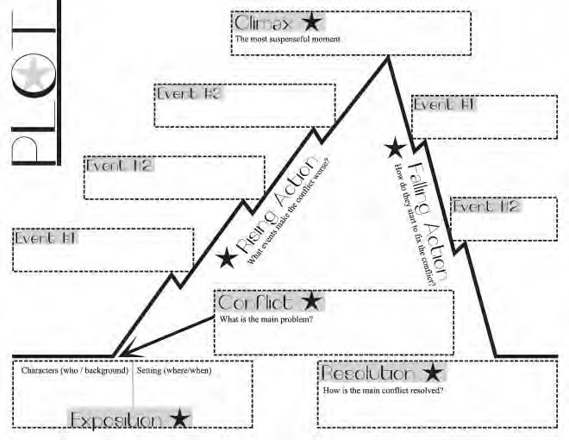

**Activity Sheet 12 – Story Structure**

Can you identify what happens in the Exposition, Conflict/Problem, Rising Action, Climax, Falling Action, and Resolution of the story?

Exposition:

Conflict:

28



**Activity Sheet 12 (continued)**

Rising Action – what events take place here?

Climax

Falling Action – what events take place here?

Resolution

29

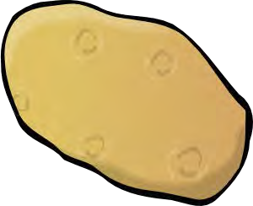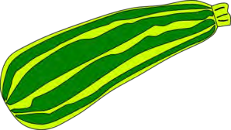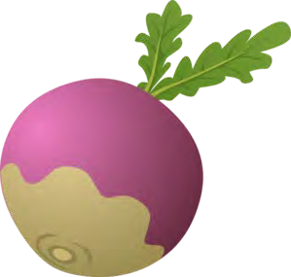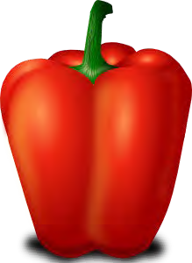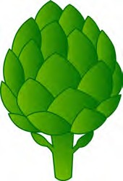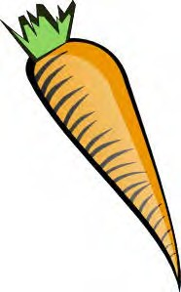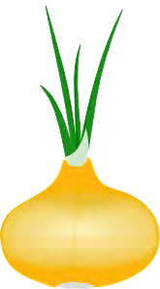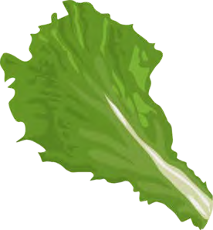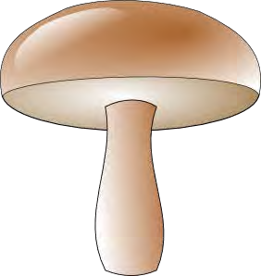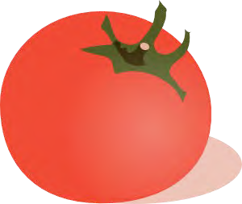

**Activity Sheet 13 – The Kailyard**

1. Can you identify which of these things would have been grown in Rab’s family kailyard? Discuss the reasons for your choices.

carrot

potato

sweet pepper

artichoke

courgette

aubergine

onion

kale

tomato

mushroom

leek

turnip

2. What other food items would Rab’s family have produced themselves on the farm and in the kitchen?

30



**Activity Sheet 14 – Local Plants**

As a class outing, or on your way to school, see if you can gather up the following to bring into school for comparison and discussion:

•

•

•

•

•

Five types of leaf (from trees or bushes)

Four types of wild flower (not from a garden!) Three types of wild grass stalks

Two types of wild berry

One type of seed (this can be a nut from a tree such as a chestnut or acorn, or the seed of a flower such as a dandelion)

Don’t worry if you can’t find them all – what you can gather will depend on the time of year.

CLASS DISCUSSION:

Compare what everyone has found. How many different types of leaves, flowers, seeds, etc did your class find? Can you identify each of them using pictures on the internet to help you?

In the story, Rab mentioned an oak tree and horse chestnut trees. Did anyone find either of these leaves? Draw a picture of both of these leaves below, and discuss the differences between them.

31



**Activity Sheet 15 – Book Cover Design**

Write down all of the words, phrases, objects and names that interest you from the book.

Can you come up with your own title for the book? Why would you choose this?

32



**Activity Sheet 15 (continued)**

Now draw your own version of a book cover for the story:

33

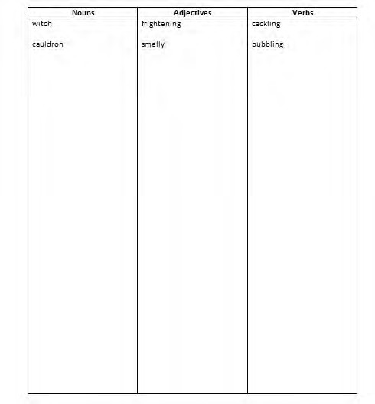

**Activity Sheet 16 – Halloween Poem**

Brainstorm all of the words you can think of to do with Halloween, and write them in the correct place in the table. The first few have been done to help get you started:

Now go through your list again, and see if you can find a word that rhymes with each of the nouns, adjectives and verbs you’ve written down. For example, ‘itch’ rhymes with ‘witch’, and ‘jelly’ rhymes with ‘smelly’!

34



Activity Sheet 16 (continued)

Use the rhyming words you’ve come up with to write your own poem about Halloween. It can be spooky or funny, long or short, and it can be about a real life experience or something made up:

35