

*14th*

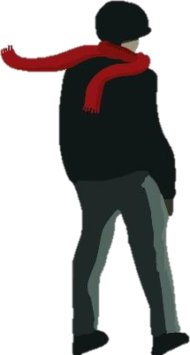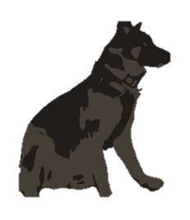

***War of the Wind***

***Alternative Book Cover***

***Rules***

Join Max, Beanie, Erin

wind turbines and stop

& David on an adventure to shut down the

the sinister scientist, Doctor Ashwood!

*of War*

*of the*

*Wind*

Celebrate

the

release

by

entering

our

photography and drawing competition for an alternative book cover.

For your chance to win superb scientific prizes as well as a signed copy of War of the Wind, all you need to do is submit your spooky photos or drawings using the email or postal address below. We will turn these into an alternative War of the Wind book cover and post

them on our website, social media and on the authors website.

***How To Enter:***

•

Draw or capture a spooky shot on your phone/camera of a

wind turbine and submit it to Neem Tree Press.

This competition is open to pupils in Year 6 to Year 9 / P6 to S3.

To enter the competition, you must be a resident of England,

•

•

Scotland, Wales or Northern

Entry form below must be

school, alongside the drawing

Ireland.

completed with pupil name and

of a wind turbine or photograph.

•

(Please make your pictures as large as possible.)

Only one competition entry per person.

•

•

Make sure you send us your entry by

October 2022

for your chance to win one of our fantastic prizes. Good Luck!

***24th***

***Submission via email***

Submit your photos and the entry form via email to

[competitions@neemtreepress.com](mailto:competitions@neemtreepress.com)

***Submission via Post***

If you would like to submit your drawing or photograph via post, please use the email above for the address and submit with the

entry form.

***Prize:***

The prizes are as follows:

* First place winner: A build your own Turbine Kit and a signed copy of War of the Wind by Victoria Williamson.
* 2 x Runners up: Photography Skills Book or How-to- Draw Book and a signed copy of War of the Wind by

Victoria Williamson.

* 5 x Commended Prizes:

A signed copy of War of the

Wind by Victoria Williamson.

***Winners will be announced on Monday***

***October 2022.***

By entering our competitions, you agree to our competition [**terms**](https://www.natgeokids.com/uk/kids-club/cool-kids/general-kids-club/standard-competition-ts-cs/)

[***and conditions*** *on our website.*](https://www.natgeokids.com/uk/kids-club/cool-kids/general-kids-club/standard-competition-ts-cs/)

***Entry Form***

Please fill in the details below and send to Neem Tree Press when

submitting your photo / drawing.

***First Name:***

***Class:***

***School Address:***