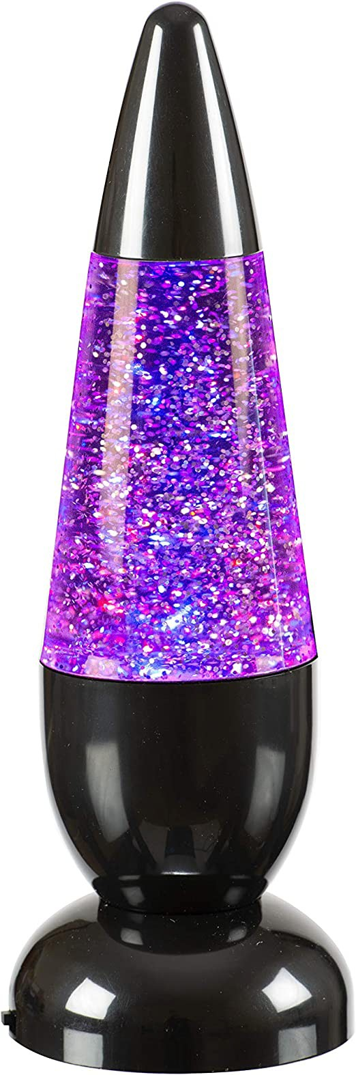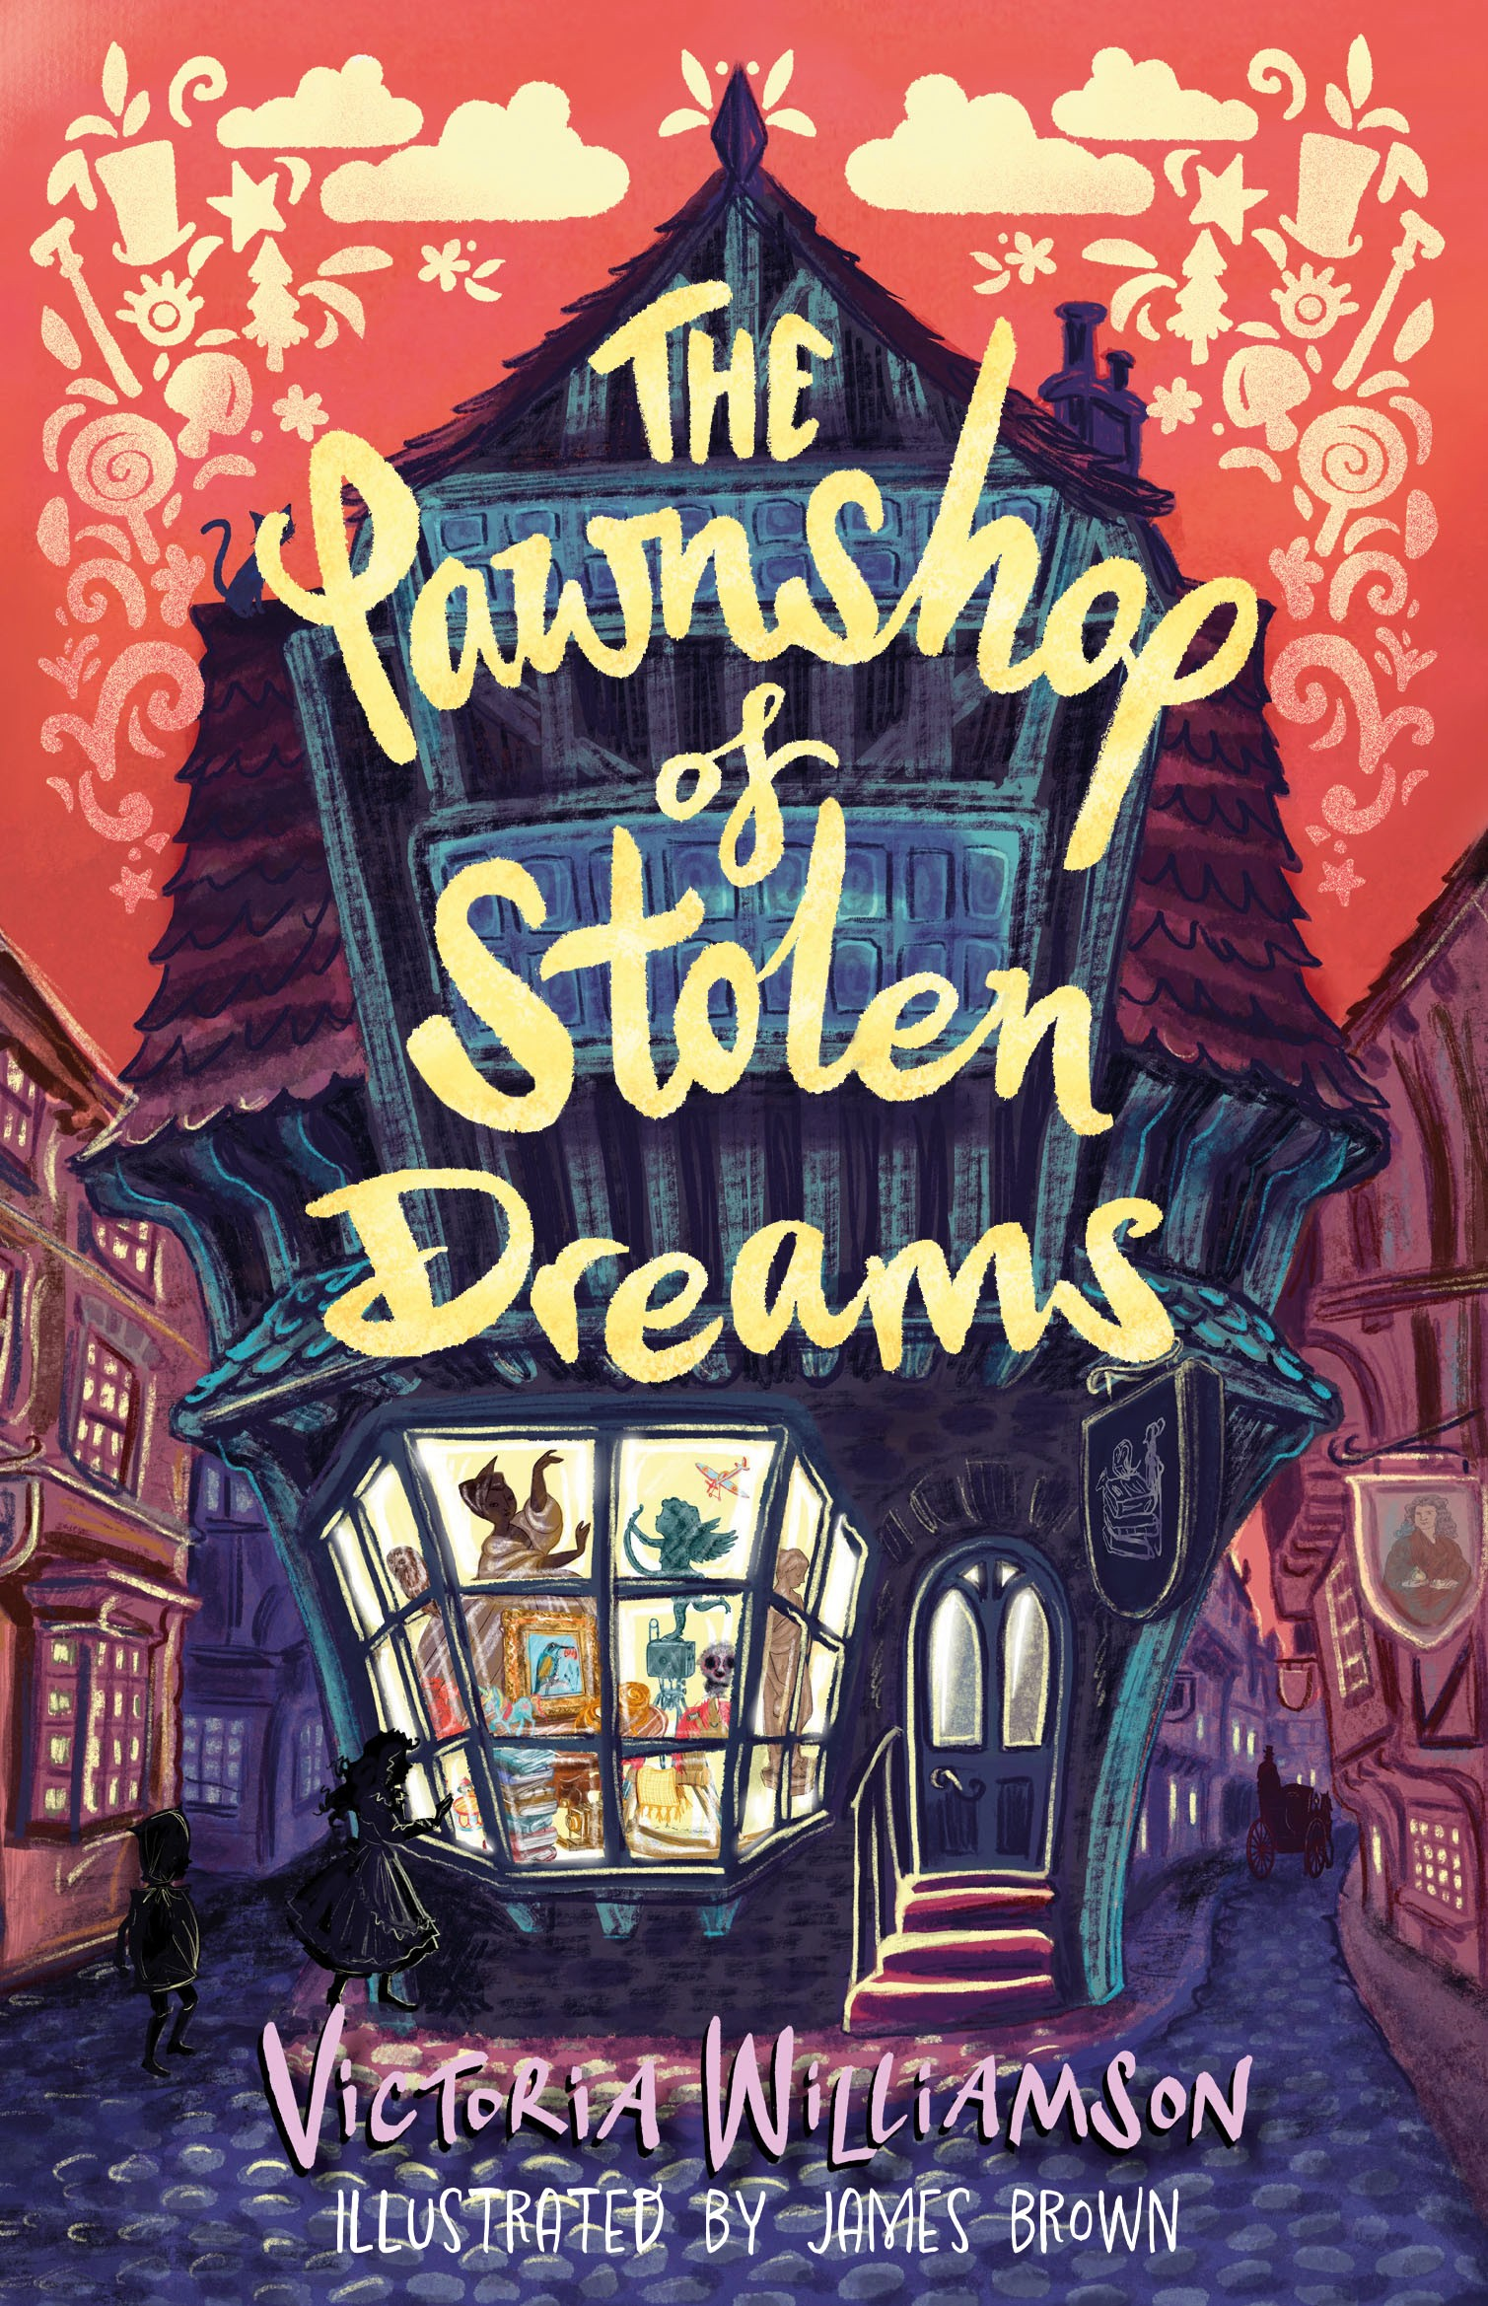

*The Pawnshop of Stolen Dreams*

Daydream Competition

Entry Form

Name: Class:

School Address:

Draw a picture of your daydream ingredients - fill the whole box or draw them all

on a separate piece of paper if the box isn't big enough. Don't forget to label them!

What daydream will these ingredients give you?