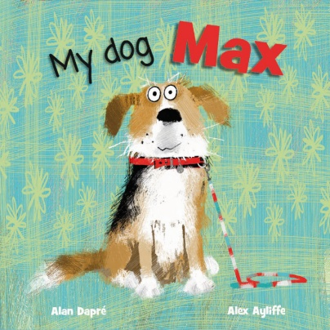
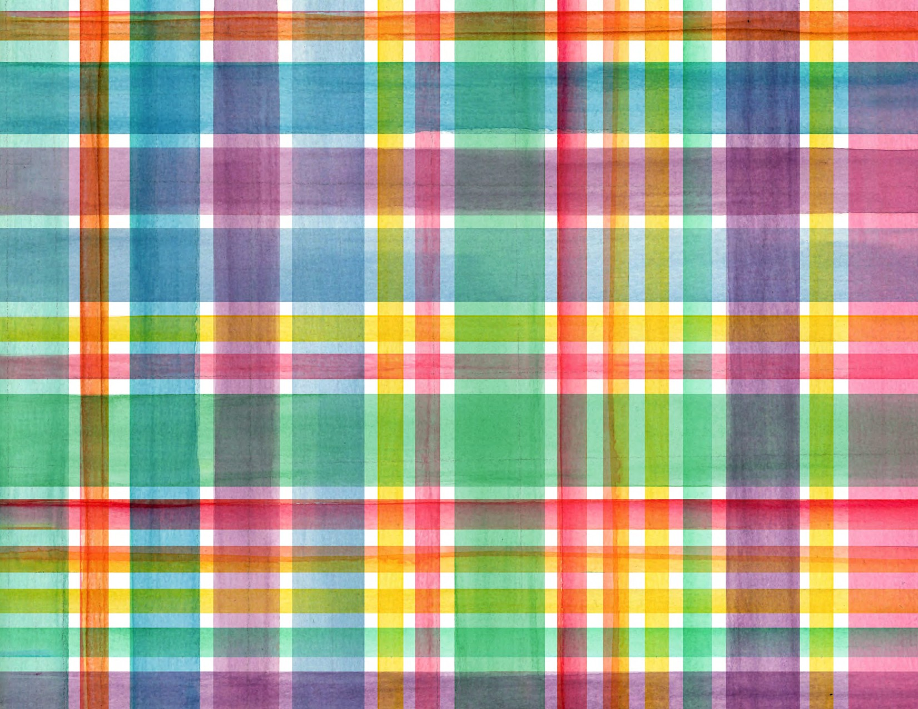

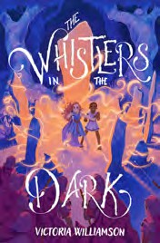
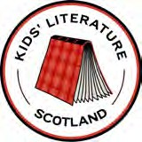
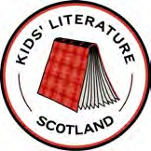
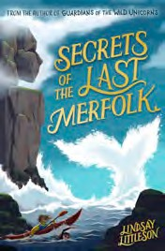
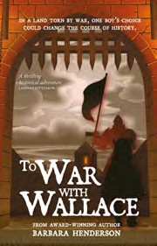
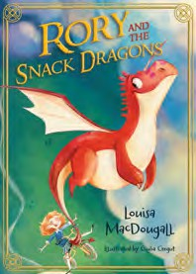
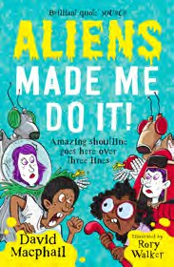
Adventure at a Scottish Landmark - Comic Competition
If you could visit any place in Scotland, where would you go? If you had an amazing adventure there, what would happen?
Would it be mysterious, magical, surprising or scary?
Could you draw a comic strip to show people what happened on your adventure?
RULES:
Competition is open to pupils in P3-P7
-
- One entry per pupil - use either the attached comic strip templates or draw your own
- Postal entries and scans must arrive by the closing date: Friday 5th June
- For details of how to submit entries, please email: kidlitscotland@gmail.com
- Winners will be announced on Monday 15th June
Six winners will receive a copy of one of the following books for their classroom shelf:
My Dog Max -
Alan Dapre
Rory and the Snack Dragons - Louisa McLennan
Aliens Made Me Do It -
David Macphail
Secrets of the Last Merfolk -
Lindsay Littleson
The Whistlers in the Dark -
Victoria Williamson
To War with Wallace -
Barbara Henderson

